Project Design Phase
Solution Architecture

Date | 30TH SEPTEMBER
Team ID | SWTID-2026-7353
Project Name | AI BlogNest API
Maximum Marks | 4 Marks

Solution Architecture of AI-BlogNest
AI-BlogNest is an AI-powered blog management application designed to help users create, manage, view, and summarize blog content efficiently. The system combines a web application backend with a database and AI service to provide automated blog generation and summarization.
Architecture Components
- User
  - Registers and logs into the application.
  - Creates and manages blog posts.
  - Provides a topic or prompt for AI blog generation.
  - Uses the summarization feature for blog content.
  - Views completed blogs.
- Frontend / Client
  - Provides the user interface for interacting with the application.
  - Sends user requests to the backend API.
  - Displays generated blogs, summaries, and stored blog posts.
- Backend / API Server
  - Handles application requests and business logic.
  - Manages user registration and login.
  - Handles blog creation and retrieval.
  - Communicates with the database.
  - Sends AI generation and summarization requests to the AI service.
- MongoDB Database
  - Stores user information.
  - Stores blog details and content.
  - Maintains completed blog posts.
  - Provides persistent storage for the application.
- AI Service
  - Generates blog content from the user's topic or prompt.
  - Summarizes existing blog content.
  - Returns AI-generated responses to the backend.

Solution Architecture Diagram:

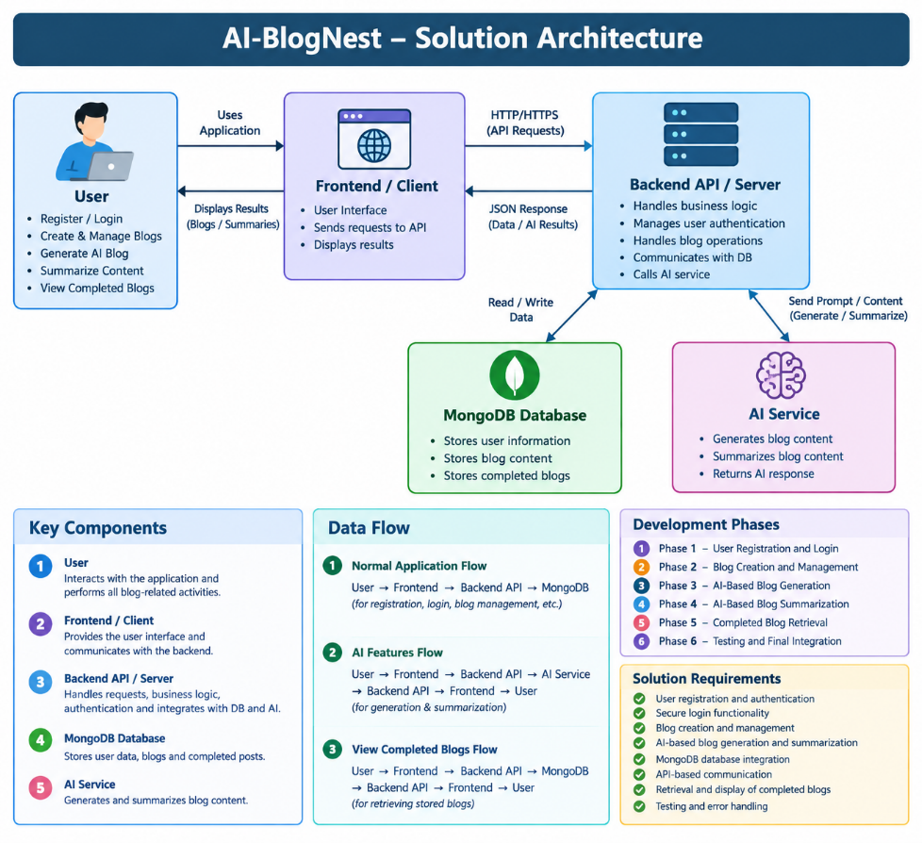
Development Phases
- Phase 1: User Registration and Login
- Phase 2: Blog Creation and Management
- Phase 3: AI-Based Blog Generation
- Phase 4: AI-Based Blog Summarization
- Phase 5: Completed Blog Retrieval
- Phase 6: Testing and Final Integration
Solution Requirements
- User registration and authentication
- Secure login functionality
- Blog creation and management
- AI-based blog generation
- AI-based blog summarization
- MongoDB database integration
- API-based communication between frontend and backend
- Retrieval and display of completed blogs
- Testing and error handling

Reference: https://aws.amazon.com/blogs/industries/voice-applications-in-clinical-research-powered-by-ai-on-aws-part-1-architecture-and-design-considerations/

